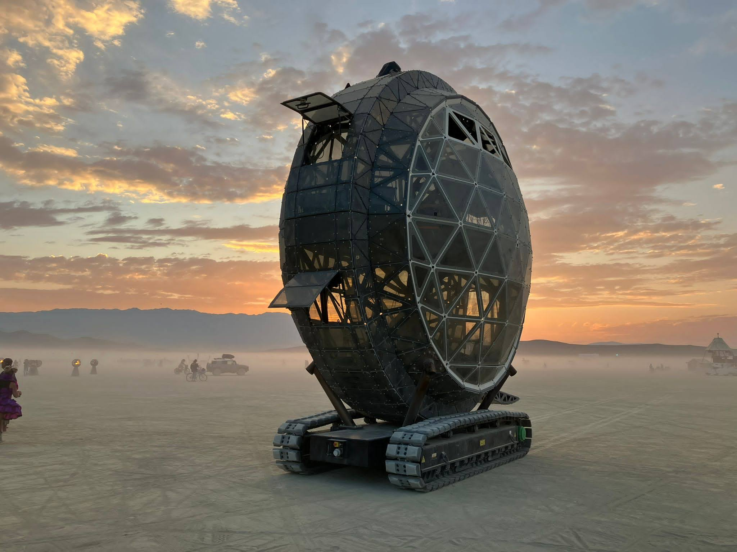

Mothership Spec Sheet

**Physical Specifications:**

Height: 22ft 2in

Length: 20ft without ramp, 23ft including lowered ramp

Width: 8ft

Weight: 12 tons (24,000 lb)

Track Composition: Rubber

Ground Pressure: Maximum 12 psi on very hard surfaces, Minimum of 4 psi on soft surfaces

A standard passenger car is 30+ psi

**Assembly Specifications:**

Trailer Length: 53ft

Trailer Type: Removable Gooseneck Minideck Equipment Trailer  
Over The Road Weight: ~

Equipment Required: 12,000 lb rated Telehandler or crane with 10,000lbs or greater lifting capacity

Time to assemble: 6 hours

**Lighting Specifications:**

LEDs: 83,000 SK9822-EC20 LEDs at 5mm pitch running at 60FPS, large custom library of sound reactive patterns

Lasers: 2 or 3 Spectrum 33 RGBY lasers

Movers: 2 Elation Proteus Excalibur moving head lights

**Power Specifications:**

Drivetrain: All electric battery powered

Battery Capacity: 96 kWh, suggested max use 77 kWh

Onboard Power: Inverter pulling from onboard batteries

Shore power: 1 x 50 amp Hubbell CS6365 “Cali 50” circuit running at 120V to run lights

Charging power: Five wire camlocks running at 120v with at least 100 amp service